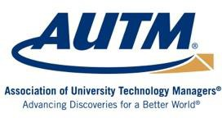

AUTM Chair, Newly Elected Board Members and Treasurer Take Office

Phoenix, Arizona – February 21, 2018 —The Association of University Technology Managers, (AUTM), an international non-profit whose 3,200 members support academic research globally, shepherding innovations from the lab to the marketplace, has welcomed Alison Campbell, Director of Knowledge Transfer Ireland (KTI), as its new Chair, and three new Directors and a new Treasurer to its Board.

Campbell started her career in the biotech industry. She then occupied a variety of academic-industry interface positions, most significantly as CEO at Medical Research Council Technology, UK, and at King’s College London where she led technology transfer and research support. Most recently, at KTI, the Irish national office, she has been responsible for policy, practice and the performance of the Irish knowledge & technology transfer (KTT) system, governed through the Irish Universities Association in conjunction with Enterprise Ireland.

Campbell is a founder and immediate past-Chair of the Alliance of Technology Transfer Professionals (ATTP), the body that sets the global standards for the profession and awards the Registered Technology Transfer Professional (RTTP) credential. Previously, as Chair of Praxis in the UK she led the merger with Unico and for many years led its professional development activities. Campbell has served as a non-executive director on a number of companies and acted as an international advisor to government departments. Alison was awarded an OBE in 2010 (UK) in recognition of her contribution to Knowledge Transfer.

She spoke Wednesday at AUTM’s Annual Meeting in Phoenix, Arizona, sharing with the conference’s more than 1,750 attendees the details of new initiatives to strengthen and expand the organization’s work internationally.

“The AUTM community is global,” Campbell said. “We have more than 3,000 members from 61 different countries. But the number of people who engage with AUTM across the world is much larger. This year, we’ll take a look at our international portfolio and ask the questions – ‘who, how and why?’ The objective is to refresh our international strategy so that it works to further support technology transfer worldwide.”

“Alison has a wealth of experience in technology transfer, which is the cornerstone of our great Association,” said AUTM CEO Stephen Susalka. “Her strategic outlook, coupled with her international experience, provide an exceptional perspective as the profession evolves globally.”

Richard Chylla, PhD, CLP, RTTP, Executive Director, Michigan State University, MSU Technologies, was Tuesday selected as AUTM’s Chair-Elect, and will succeed Campbell when she steps down as Chair in February 2019.

Joining the Board are three newly installed Directors who were elected to three-year-terms:

- Joann MacMaster, MBA, RTTP, Director of Business Development, University of Arizona, Tech Launch Arizona
- Laura Savatski, MBA, CLP, RTTP, Technology Transfer Officer, BloodCenter of Wisconsin, Inc.
- Sharon E. Semones, Advisor, Eli Lilly and Company

Also joining the Board is a new Treasurer, who was elected to a three-year term:

- Graham Morton, RTTP, Director, Quantifex Pty Ltd. and Kakadu Software Pty Ltd., Sydney, Australia

About AUTM
AUTM is the non-profit leader in efforts to educate, promote and inspire professionals, throughout their careers, to support the development of academic research that changes the world. AUTM’s community is comprised of more than 3,200 members who work in more than 800 universities, research centers, hospitals, businesses and government organizations around the globe. To learn more, visit www.AUTM.net.

Editor’s Note
Photographs are attached.

Media Contacts
Leef Smith Barnes
lsmithbarnes@autm.net
703-870-4895

Paul Stark pstark@autm.net
312-560-5643

‒ ‒ ‒ # # # ‒ ‒ ‒

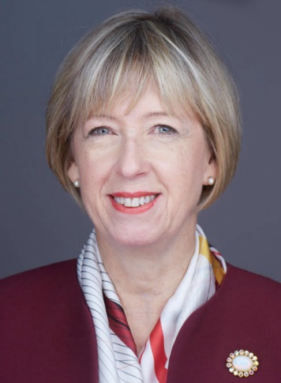 | 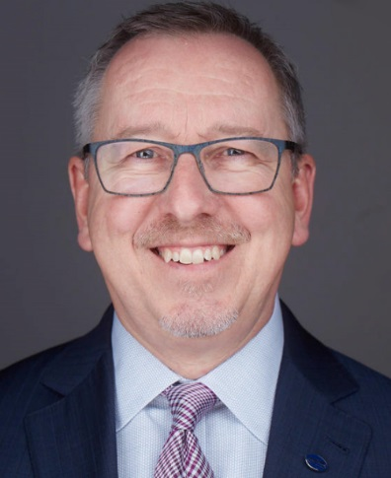 | 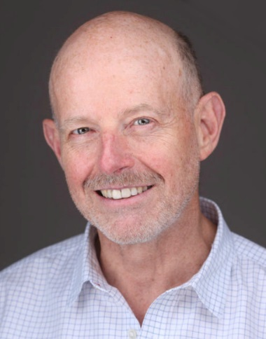
Alison Campbell | Richard Chylla | Graham Morton

 |  | 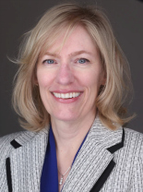 | 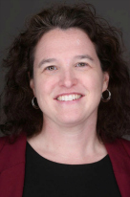
Laura Savatski |  | Joann MacMaster | Sharon E. Semones

